
University of Virginia Center for Politics

Presidential Election 2020: Economy and Politics

Purpose: The state of the economy during the presidential election season has a significant impact on not just the approval rating of the incumbent president at the time, but also has an impact on the policies in which presidential candidates run on. Additionally, the state of the economy also influences who will come out to vote in that year. This year, 2020, it is just one of many factors that may affect voter turnout but the economy may be underestimated. This exercise will encourage students to evaluate how other fluctuations in the economy may affect the ratings, policies, and decisions of the 2020 presidential candidates.

Objectives:

- Students will be able to analyze the relationship between United States politics and the state of the nation’s economy.
- Students will navigate through the “Peaks and Valleys: Economics and Politics” activity in order to interpret how specific fluctuations in the economy affect presidential candidates.
- Students will identify key economic indicators and what they tell voters about the U.S. economy.
- Students will be able to make predictions about how the economy will affect the outcome of the 2020 presidential election, specifically in terms of the economy.

Key Words:

Economic Indicator Gross domestic product (GDP) Incumbent
External Shock

Materials:

- Gallup Poll website: http://www.gallup.com/tag/Economy.aspx
- Game Resource, Peaks and Valleys: Economics and Politics
- Teacher Resource, Economic Statistics and Presidential Politics
- Student Resource, Brace Yourself: The Presidential Election is Going to be All About Anger.
- Student Resource, Everyday Economic Indicators
- Student Resource, Student Crystal ball: Making a Presidential Prediction from Economic Factors
- Teacher Resource, Election 2020: Politics, Covid-19 and the Economy

Procedure:

- As a homework assignment prior to beginning this lesson, ask students to poll potential anonymous voters using the following questions:
Do you plan to vote in 2020?
If yes, how important are economic conditions to your decision to vote?
If no, how important are economic conditions to your decision not to vote?
Explain.
Who do you blame for the current economic conditions? Why?
*Have the students share their responses from the poll.
- Visit https://news.gallup.com/topic/economy.aspx and analyze Gallup’s poll data on current economic conditions.
- Distribute the Game Resource, Peaks and Valleys: Economics and Politics. Divide students into groups of four or five and play the game following the directions provided. Following the game, ask them:

What did you learn about Presidential politics from playing the game?
Do you think this game accurately reflects what might occur in 2016?

- Display Teacher Resource, Economic Statistics and Presidential Politics.
- What generalizations can be made about economic statistics and the Presidential race?
- How important are good economic conditions to the incumbent candidate? Challenger?
- Why?

- Distribute the Student Resource, Brace Yourself: The Presidential Election is Going to be All About Anger. Discuss the following as a class:
- What is the main idea the author is trying to convey in the article?
- What evidence does she give to support this claim?
- Based on what you have read, what will determine who voters will elect for President in November?

- Have students go to the following URL, http://www.kiplinger.com/tool/business/T019-S000-kiplinger-s-economic-outlooks/. This page summarizes the formal economic indicators used by economists to make predictions about the economy. These economic indicators provide information about the strength or weakness of the American economy.

- Household Income
- Household Net Worth
- Employment
- Wages
- Consumer Confidence
- Housing Prices

Based on what you see on the website, how do you think most voters feel about the economy?
How can we find out how voters in our community feel about the economy?

- Using, Everyday Economic Indicators guide students to come up with their own strategies for gauging economic confidence. As an assignment, have them use one of the indicators listed on the resource or an indicator of their creation to make a prediction about the U.S. economy and its effect on the upcoming Presidential race.

- Ask students to summarize what they have learned about the correlation between Presidential politics and the economy by having them make a prediction about the 2020 Presidential race based solely upon economic indicators. As you move through the campaign season, follow economic data and discuss whether or not their predictions were correct and how that might affect the election on November 3rd. Pass out the student resource, Student Crystal Ball: Making a Presidential Prediction from Economic Factors.

Subscribe to Larry Sabato’s Crystal Ball website for free updates on the Presidential race.
http://www.centerforpolitics.org/crystalball

Game Resource

Peaks and Valleys

Rules of the Game:

- Each player of the game should choose a “character” to be for the duration of the game. Only 3 people can play this game at a time. Each character has a unique pile of cards you choose from to advance in the game. The character you choose to be for the game determines which pile of cards you choose from for the rest of the game. Also, it is very important that each player of the game choose characters that would represent a real presidential election. For example, one player cannot be the Democratic Incumbent President while another is the Republican Incumbent President.
- The Incumbent President will always start off the game – if there is an incumbent playing. If not, the person to start off the game will be determined by rolling a dice (The person with the higher number on his/her roll will begin the game).
- Each time it is your turn, you will roll the dice to determine how many spaces you move forward. Then, draw one card from your pile. The cards will describe a situation in which the state of the economy has influenced your presidential campaign, and can cause your character (and the others) to move forward or backward. Follow the dates on the calendar according to the black arrows.
- The goal of the game is to beat the others to the end of the board, which represents the result of the Presidential Election on November 8th, Election Day.
- There are spaces along the board that have separate directions for your character to travel if you land on them. This is where the “Peaks” and “Valleys” become relevant to the game. If you land on a “peak,” then the direction will tell you to advance on the board. If you land on a “valley,” you will, unfortunately, lose many spaces on the board.
- If a player goes through all of the cards in his or her pile before there is a winner of the game, simply shuffle the cards and continue to go through the pile until the game is over.

Have Fun!
Peaks and Valleys:

CHARACTER PIECES:

(Please cut out pieces)
INCUMBENT
1
NEW
CANDIDATE1
THIRD
PARTY 1
INCUMBENT
2
2PRESIDENT
NEW
CANDIDATE 2
THIRD
PARTY 2

Politics and the Economy

ELECTION DAY!

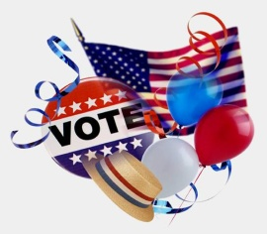  6 | 5   | 4  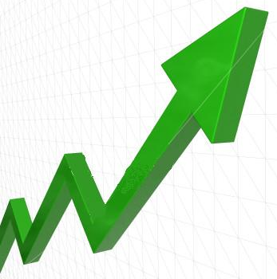  S  K  A  E  P | 3 | 2
28 | 29 | 30 | 31 | 1
27  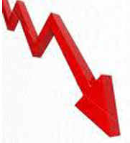  V  A  L  L  E  Y  S |   26 |   25 | 24 | 23
18 | 19 | 20 | 21   | 22
  17  START | 16 |   15 | 14 | 13
8 | 9 | 10 | 11 | 12

Information for the Cards:
Incumbent President

Incumbent President

“Unrest breaks out in Saudi Arabia, driving gas prices up during the presidential election season. Opposing candidates hold the incumbent responsible for this in the national media. The incumbent’s approval ratings drop by 4% in the national polls.”

Incumbent—Lose 2 spaces, Candidate—Gain 1 space, Third party—Remain in current space

Real Life Example: “Obama's approval rating is down to 46% in the survey, in large part because of one issue: rising gas prices.” –

http://content.usatoday.com/communities/theoval/post/2012/03/gas-prices-rise-obamas-approval-rating-sinks/1.

Incumbent President

“Gas prices decrease as a result of a recent successful policy of less dependence on foreign oil. The American people attribute the success to the incumbent’s administration. The incumbent’s approval ratings increase by a whopping %6 nationwide. ”

Incumbent—Gain 3 spaces, Candidate—Lose 1 space, Third party—Gain 2 spaces (large support of environmental friendliness.)

Real Life Example: “Analysts expect gas prices to peak in late April or early May [2012]. Then, prices could slowly begin to fall.”

(http://www.nbcwashington.com/news/local/Experts-Gas-Prices-Going-Down-Soon-143317926.html). Obama’s approval ratings may go up as a result
Incumbent President

“Unemployment levels increase nationwide. The incumbent is blamed for not putting enough pressure on Congress for passing policies that would stimulate the economy. Approval ratings decrease to 40% nationwide.”

Incumbent—Lose 2 spaces, Candidate—Gain 2 spaces, Third party—Gain 1 space

Real Life Example: “U.S. unemployment… increased to 9.1% in February from 8.6% in January...”
(http://www.gallup.com/poll/153161/unemployment-february.aspx)

“President Obama's average job approval rating for the month of February… was 45%, with 47% disapproving…” (http://www.gallup.com/poll/153152/Obama-Approval-Averages-February.aspx)
Incumbent President

“Unemployment rate decreases nationwide this month and the incumbent’s approval ratings in the Gallup polls soar!

Incumbent—Gain 3 spaces, Candidate and Third party— Remain in current space

Real Life Example: “U.S. unemployment… declined to 8.4% in March from 9.1% in February…”

(http://www.gallup.com/poll/153761/Unemployment-Declines-March.aspx)

“The [Gallup’s] analysis suggests that if economic confidence rises in the coming months, President Barack Obama's job approval rating will likely rise as well.” (http://www.gallup.com/poll/153335/Obama-Job-Approval-Tied-Economic-Confidence-2012.aspx)

Incumbent President

“Stock market crashes, signaling in another decade of recession for the country. As a result, the incumbent’s approval ratings hit an all-time low.”

Incumbent—Lose 3 spaces, Candidate and Third party—Gain 1 spot each

Real Life Example: “The Great Depression that struck during the "Great Engineer's"[Herbert Hoover’s] presidency, and his inability to do much about it, had changed the national mood and its political temper.”

(http://millercenter.org/president/hoover/essays/biography/3)
Incumbent President

“Gallup Polls report that during your presidency the Global National Product (GNP) has increased significantly. The major news networks report this information to the American people and the incumbent’s approval ratings go up!”

Incumbent—Gain 3 spaces, Candidate and Third party—Lose one spot each

Real Life Example: “The economy came out of recession just in time for Reagan's reelection bid, as real GNP grew a robust 7.19% in Reagan's final year of his first term.”

(http://economics.about.com/cs/macroeconomics/a/presidency_2.htm)

Incumbent President

“The incumbent’s economic policy to stimulate job growth in America’s economy was just recently passed with bipartisan support. It receives very little criticism for the bill from the media.”

Incumbent—Gain 2 spaces, Candidate and Third party—Remain in current space

Incumbent President
“As unemployment rises, the incumbent advocates for a progressive tax – higher taxes for the richer and lower for the poorer. The incumbent’s approval ratings go up amongst the lower and middle class citizens, but end up losing support from the upper class citizens.”

Incumbent – Gain 1 space, Candidate – Gain 1 space, Third Party – Remain in current space.

Real Life Example: “By the current policy measure, Obama would raise taxes for about a third of households in 2015 and cut them for about one in six. For most of those who would pay more tax, the increase would be small, mostly just their share of higher business taxes.”

(http://taxvox.taxpolicycenter.org/2012/03/21/will-obamas-2013-budget-raise-or-lower-taxes-yes/)

Candidate for President (non-incumbent)

Candidate for President (non -incumbent)
“Gas prices increase and the approval ratings for the Democratic incumbent president plummet. The Candidate’s campaign seizes the opportunity to take the upper-hand on the issue of economy in the presidential election. Approval ratings for the Candidate increase as a result.”

Candidate—Gain 2 spaces, Incumbent—lose 2 spaces, Third party—Remain in current space

Real Life Example: “As gas prices creep to $4 per gallon around Syracuse, and in some areas around the country even higher, the Republican presidential candidates have decided to use gas prices to attack President Barack Obama.” (http://www.dailyorange.com/opinion/liberal-presidential-hopefuls-unfairly-criticize-obama-for-rising-gas-prices-1.2827190)
Candidate for President (non incumbent)
“After a week of negative ads running against the incumbent president criticizing his economic policies, Gallup polls report a decrease in the national unemployment rate. The Candidate’s approval ratings decrease as a result.”
Candidate—Lose 2 spaces, Incumbent—Gain 1 space, Third party—Remain in current space
Real Life Example: “Democrats have tried, in several ads over the past few weeks, to go on the energy offensive, pinning the blame of high gas prices on oil companies and specifically Mitt Romney.” (http://www.thedailybeast.com/articles/2012/04/05/obama-ad-pins-high-gas-prices-on-romney-candidate-of-big-oil.html) – Not a direct example, but a very similar one.
Candidate for President (non incumbent)

“In an important debate, the incumbent president points out a vote the Candidate made while in congress supporting a bill that went on to hurt the economy, rather than help.”

Candidate – Lose 2 spaces, Incumbent and Third party—Gain 1 space

Candidate for President (non incumbent)
“As the unemployment rate rises, the Candidate advocates a policy that would cut taxes for businesses that are trying to stimulate the economy. The Candidate’s approval ratings go up amongst the upper-middle and upper class citizens while this policy doesn’t resonate as well with the lower classes.”

Candidate – gain 1 spot, Incumbent – gain 1 spot, Third Party – Remain in current space.

Real Life Example: “The former president repeated the argument often used by Republicans -- that eliminating those tax cuts for the wealthy, as Democrats have proposed, would hit small businesses and hurt hiring.”

(http://money.cnn.com/2012/04/10/news/economy/bush-speech/)

Candidate for President (non incumbent)

“During the incumbent’s 4 years presidency the federal deficit increased by 100 billion dollars. The Candidate is able to use this information against the incumbent and approval ratings increase nationwide.”

Incumbent – lose 2 spaces, Candidate – Gain 2 spaces, Third Party – gain 1 space.

Candidate for President (non incumbent)
“The Candidate’s tax returns are released to the public, showing the immense amount of investment wealth they have accumulated and thus avoiding the same tax rate as those who live off of an income. The Candidate is seen as being disconnected from the average American economic struggles and loses approval nationwide.”
Incumbent – Gain 1 space, Candidate – Lose 2 spaces, Third Party – Gain 1 space.
Real Life Example: “None [of Romey’s fortune] came from wages, the primary source of income for most Americans. Instead, Romney and his wife, Ann, collected millions in capital gains from a profusion of investments, as well as stock dividends and interest payments.” (http://www.washingtonpost.com/politics/mitt-romney-releases-tax-returns/2012/01/23/gIQAj5bUMQ_story.html)

Third Party Candidate:

Third Party Candidate

“Incumbent president is blamed for failed economic policies as unemployment rates drop and dependence on foreign oil is unchanged. As a result of the state of the economy, the third party candidate’s economic policies about more drilling in the U.S. and less government intervention are taken much more seriously. Approval ratings increase nationwide.”

Third party Candidate—Advance 2 spaces, Incumbent and Candidate—Remain at current position

Third Party Candidate

“The Sierra Club along with the Nature Conservancy endorses the Green Party Candidate for advocating a “green industry,” creating an entirely new field of jobs as well as working towards limiting the nation’s carbon emissions.”

Third Party – advance 2 spaces, Incumbent and Candidate – remain at current space.

Real Life Example: “The Green Party of the United States today inaugurated a website publicizing the major endorsements Green candidates have received from prominent labor, environmental and social justice organizations, as well as daily newspapers.”

(http://www.gp.org/press/pr_10_31_02.html)

Third Party Candidate

“An anti- war rally breaks out at the capitol. The incumbent president has worked hard to pull out of war and avoid future conflict; however people say it is not fast enough. The Candidate and
third party candidate both originally voted in favor of the war in congress, and are see as pro-war candidates.”
Incumbent—Lose 1 space, Candidate and Third party—Lose 2 spaces.
Third Party Candidate

“The incumbent points out attacks made on the Candidate by their own
party during the primary race for nomination. This stirs up old
conflict within the Candidate’s party.”
Incumbent—Gain 1 space, Candidate—Lose 2 spaces, Third party—Remain in
current space.

Third Party Candidate

“In a debate the Candidate and Incumbent both appear to be talking down
to the lower class of the country. People view them as high upper
class, therefore not in full understanding of the lower classes
conditions.”
Incumbent and Candidate – Lose 2 spaces, Third party-- Gain 1 space.

Teacher Resource

Unemployment Rate in Presidential Election Years

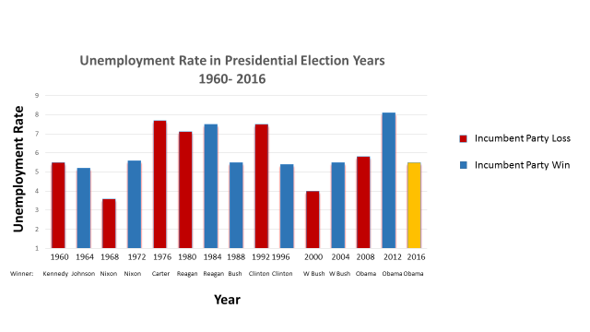

- Only time since 1960 an incumbent president has won re-election with an unemployment rate above 7% was President Ronald Reagan in 1984.
- Of the seven presidential elections since 1960 that have seen around 5% in unemployment rate, the incumbent party only lost twice (‘60 – Kennedy, ‘08 Obama)
  - Of the five times the incumbent party won, four were incumbent presidents (Johnson ‘64, Nixon ‘72, Clinton ‘96, George W Bush ‘04), and the other was an incumbent Vice President (Bush ‘88)
- Oddly, both times the unemployment rate was below 5% (3.6% in ‘68 and 4% in ‘00), the incumbent party lost.

What might this chart tell us about the 2020 Presidential Election?
Teacher Resource

3rd Quarter GDP Growth in Presidential Election Years

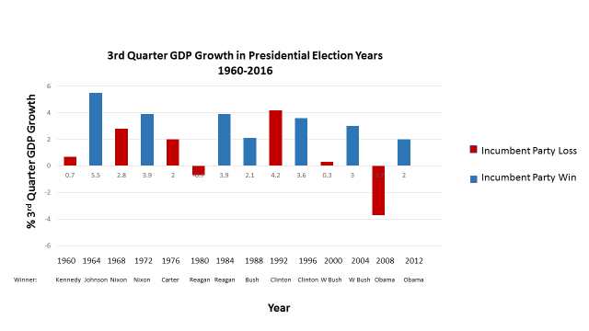

- Since 1960, no incumbent party has won presidential reelection with 3rd Quarter GDP Growth equal to or below 2%.

- Twice the incumbent party lost reelection with 3rd Quarter GDP Growth above 2%
  - 1968 – Nixon defeats Humphrey (2.8%)
  - 1992 – Clinton defeats George HW Bush (4.2%)

- What is the current GDP?

- How might this information help us to make a prediction about the 2020 Presidential Race?
Teacher Resource

Presidential Approval Rating in Presidential Election Years, 1960-2012

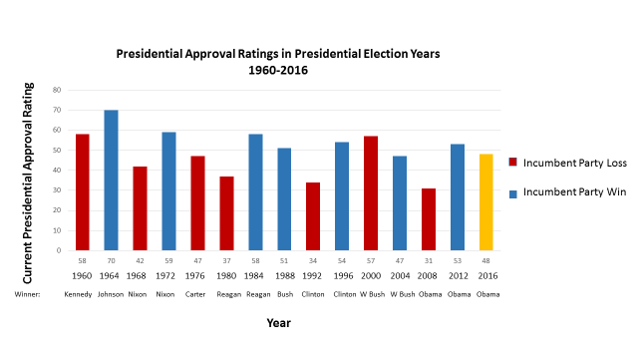

- Since 1960, only once has an incumbent party won with a president whose approval rating is below 50%....
  - ‘04 George W Bush, 47%

- Incumbent party lost the other five times
  - ‘68 Nixon [42% for Johnson]
  - ‘76 Carter [47% for Ford]
  - ’80 Reagan [37% for Carter]
  - ‘92 Clinton [34% for Bush]
  - ‘08 Obama [31% for George W Bush]
- Describe the relationship between approval ratings and incumbency in a presidential race?

- What prediction about the 2020 Presidential race might we make from this information?

Brace Yourself: The Presidential Election Is Going To Be All About Anger
http://www.npr.org/sections/itsallpolitics/2015/07/26/425981961/the-2016-election-is-all-about-economics-and-anger
Hillary Clinton laid out some lofty goals for her presidency in a speech on Friday.
"My mission from my first day as president to the last will be to raise the incomes of hardworking Americans so they can once again afford a middle-class life," she said. "This is the defining economic challenge not only of this election but our time."
So, she has her work cut out for her. But interestingly, that line came not from a populist barn burner of a speech, but from a policy-focused address about ending "quarterly capitalism" — the tendency for businesses to focus on short-term shareholder gains over long-term investment.
The wonkier bits of her speech about capital-gains taxation might only interest a specific subset of people, but she couched them to attract a much broader audience of voters angered by what they see as an unfair economic system. Democrats and Republicans alike are trying to channel that anger, but are offering very different solutions — so much so that the leading candidates for both parties seem to be living in two economic realities.
Voters are frustrated by a range of economic issues: inequality, stagnant incomes and debt, to name a few. That frustration is the driving narrative of the 2016 election, as candidates try to convince voters that they can forge an economy that won't make Americans feel stuck in neutral.
Americans have barely seen their pay outpace inflation since the recession. Annual wage growth has been stuck at around 2 percent since 2009, and median household incomes are where they were in 1995.
But that's not all that's wrong: Faith in the American Dream has dipped. In the late 1990s, 74 percent of Americans thought hard work was the way to get ahead in America. By January 2014, it was 60 percent. And since the recession, most Americans just haven't felt — for more than a handful of weeks at a time, anyway — that the economy is getting better.
Politicians, of course, have taken notice. Indeed, to win any national election, they simply have to.
"The longer we're kind of stuck in this rut of stagnating incomes and very low wage growth and a lot of slack in the labor market, the more people feel like this is just the way things are, and the less space there is for politicians to say, 'OK, well, we just need to wait for the recovery to take hold,' " said Michael Strain, a resident scholar in economics at the right-leaning American Enterprise Institute. "We've been waiting for the recovery to take hold for a while. Both parties are responding to that."
Jeb Bush earlier this year, in a speech about the middle class, acknowledged not only that Americans are frustrated, but that elbow grease can't fix everything.
"Far too many Americans live on the edge of economic ruin," the former Florida governor said, "and many more feel like they're stuck in place: working longer, and harder, even as they're losing ground."
He later added, "Something is holding them back — not a lack of ambition, not a lack of hope, not because they're lazy or see themselves as victims. Something else. Something is an artificial weight on their shoulders."
That's the idea at the center of the election, and everyone in the race seems to have latched on. Now, politicians are peering at it through their respective philosophical lenses to decide how to fix it.
"Republican rhetoric is much more growth-centric: 'The solution to this is economic growth,' "said Steven Schier, professor of political science at Carleton College."That's a very common Republican theme, whereas Democrats are more regulatory and redistributive. In other words, they're reverting to type."
Bernie Sanders has advocated higher taxes on the rich, decrying what he calls "casino capitalism" in a May interview.
"The people on top have lost any sense of responsibility for the rest of the society," said Sanders, an independent from Vermont, who has gained traction as the principal alternative to Clinton in the Democratic primary.
Marco Rubio, the Republican senator from Florida, has a tax plan that will, among other things, dole out a heftier child tax credit to some families.
Clinton believes that targeting "quarterly capitalism" and focusing on the American worker, via paid leave and helping keep mothers in the workforce, could be answers.
Bush comes at it from the other, macroeconomic direction, saying if Americans can work more hours and if government stays out of the way of the "gig economy," he can bring about 4 percent growth. That speeding train (or, perhaps, Uber car) of growth will bring everyone along with it, he contends.
It's not just about presenting policies, of course. Presidential campaigns are about choices. And in the fight to make the choice clearer for frustrated Americans, the most pointed blows yet have been between Clinton and Bush.
"Now comes Hillary Clinton, and her economic agenda could be summarized easily: Whatever Obama is doing, let's double down on it," he said in a speech earlier this month.
The implicit message: If you hate the economy now, Clinton won't change it.
For her part, Clinton and her affiliated groups have latched onto several Bush statements that could make him sound unsympathetic to workers — in particular, earlier this month, when he said that people would have to work longer hours in his economy. (His campaign later clarified that he was talking about part-time workers who want more hours.)
"Well, he must not have met very many American workers," Clinton said in response. "Let him tell that to the nurse who stands on her feet all day or the teacher who is in that classroom, or the trucker who drives all night. Let him tell that to the fast-food workers marching in the streets for better pay. They don't need a lecture. They need a raise."
While they're appealing to an exhausting stretch of stagnant wages for American workers, they're really tapping into a decades-old idea of how the economy should work.
"We're still trying to figure out how wealth gets distributed in an economy where you've seen manufacturing and union jobs and what used to be the typical middle-class blue-collar jobs evaporate," said Leonard Steinhorn, a professor of public communication and history at American University.
He continued, "The bottom line is that [politicians are] dealing with a set of expectations Americans have about the economy, and a sense of acknowledging that frustration that a great many people don't feel that they're participating in the mythical rising tide that existed briefly after World War II."
Despite newfangled campaign trail rhetoric about things like the emerging sharing economy and, yes, Uber, very old roles are at work here: Democrats championing the downtrodden laborer; Republicans bemoaning regulation.
Still, what's new in the 2016 election is really that Americans' anxiety about the economy is getting more entrenched by the day.

Student Resource

Everyday Economic Indicators

Baked Bean Sales Indicator
The Concept: Consumers move to canned goods to save on food expenses during hard times.
The Proof: During 2009, the value of baked beans soared 23% in the U.K. as consumers fell back on the staple instead of going out for dinner.
Coupon Redemption Index
The Concept: When the economy slips, consumers turn to coupons in their Sunday circulars to try to cut costs on things like toothpaste, laundry detergent and groceries.
In 2009, coupon redemption soared to 3.3 billion uses as consumers looked to save more at the market.

Hemline Index
The Hemline Index is a theory presented by economist George Taylor in 1926.Recent research suggests it is valid. The theory suggests that hemlines on women's dresses rise along with stock prices. In good economies, we get such results as miniskirts (as seen in the 1960s),or in poor economic times, as shown by the 1929 Wall Street Crash, hems can drop almost overnight.

Skyscraper Boom Indicator
Building booms will precede and then coincide with recessions, particularly when construction of a new tallest building is underway. The taller the building, the longer the crisis.
The Proof: Barclays tracks the boom in its Barclays Skyscraper Index, and the results are surprising. During the Great Depression, three of the world's tallest buildings were under construction: 40 Wall Street, the Chrysler building and the Empire State building.

Men's Underwear Index
The Concept: Men will forgo purchasing new underwear to save money during hard times.
The Proof: True. Even Alan Greenspan is on the bandwagon. Research firm Mintel estimated men's underwear sales fell 2.3% in 2009, the first time since 2003.

Desserts Index
Desserts purchased in restaurants decrease when consumers believe that the economy is about to go into a downturn. Another similar indicator tells when the economy is on the rise consumers purchase more high-priced coffees and lattes.

Lipstick Effect
The lipstick effect is the theory that when facing an economic crisis consumers will be more willing to buy less costly luxury goods. Instead of buying expensive fur coats, for example, people will buy expensive lipstick.
It has been rumored that lipstick sales doubled after the 9/11 attacks on the USA,however, other sources say this is an overstatement. In a New York Times article published May 1, 2008, Leonard Lauder is quoted as saying that he noted his company's sales of lipstick rose after the terrorist attacks. He did not claim they doubled. The underlying assumption is that consumers will buy luxury goods even if there is a crisis. When consumer trust in the economy is dwindling, consumers will buy goods that have less impact on their available funds.

Student Resource

Baltic Dry Index
Higher prices for boxes, cardboard and other shipping needs indicates more consumption by consumers and predicts a faster moving economy.

Taxi Index
When consumers feel the economy is weak they use taxis less and opt for either public transportation, like the bus or subway or walk to their destinations; but with an economic upswing more people will start to use cabs more frequently.

Golf Index
This is the first activity that consumers give up when the economy goes south. A rise in the number of golf reservations can indicate a strong economy may be in hand.

Invent your own everyday indicator:
Think of another way that you might be able to judge the health of the U.S. economy. If the economy is doing well what might you see when you go to the mall? If the economy is in a downturn what might you see when you drive through your neighborhood? Then go out into your community and use your indicator to make predictions about the economy and the Presidential election based on the information from this class. Keep data about the time, place and length of time you observed behavior.

Source:
http://econproph.net/wp/2012/05/everyday-economic-indicators-2/
Assessment

Student Crystal Ball:
Making a Presidential Prediction from Economic Factors

My
Data about the U.S. Economy:
Observations from Everyday Economic Indicators

+
My prediction about the U.S. Economy in November:

Justification:

Data about the U.S. Economy and Presidential Elections:
My prediction for the 2020 Presidential Race based on Economic Data and its relationship to past presidential races:

Justification:

